1. **Determine a meaningful name for your project.**
   1. Home Run Analytics
2. **Describe mission statement and mission objectives in English sentences.**
   1. Mission Statement: To analyze the past games of the Terrapins Baseball Team and gain insight about game results across varying games, locations, opponents, and seasons.
   2. Mission Objectives:
      1. To find the top ten games with the highest number of runs by the Terrapins Baseball Team.
      2. To find the top ten locations with the highest number of runs by the Terrapins Baseball Team.
      3. To find the top ten opponents that won most often against the Terrapins Baseball Team.
      4. To find the Terrapins Baseball Team’s average number of runs per game per season.
      5. To find which season the Terrapins Baseball Team had the highest winning percentage.
3. **Perform database analysis to design entity-relationship diagram (ERD) on Microsoft Visio:**

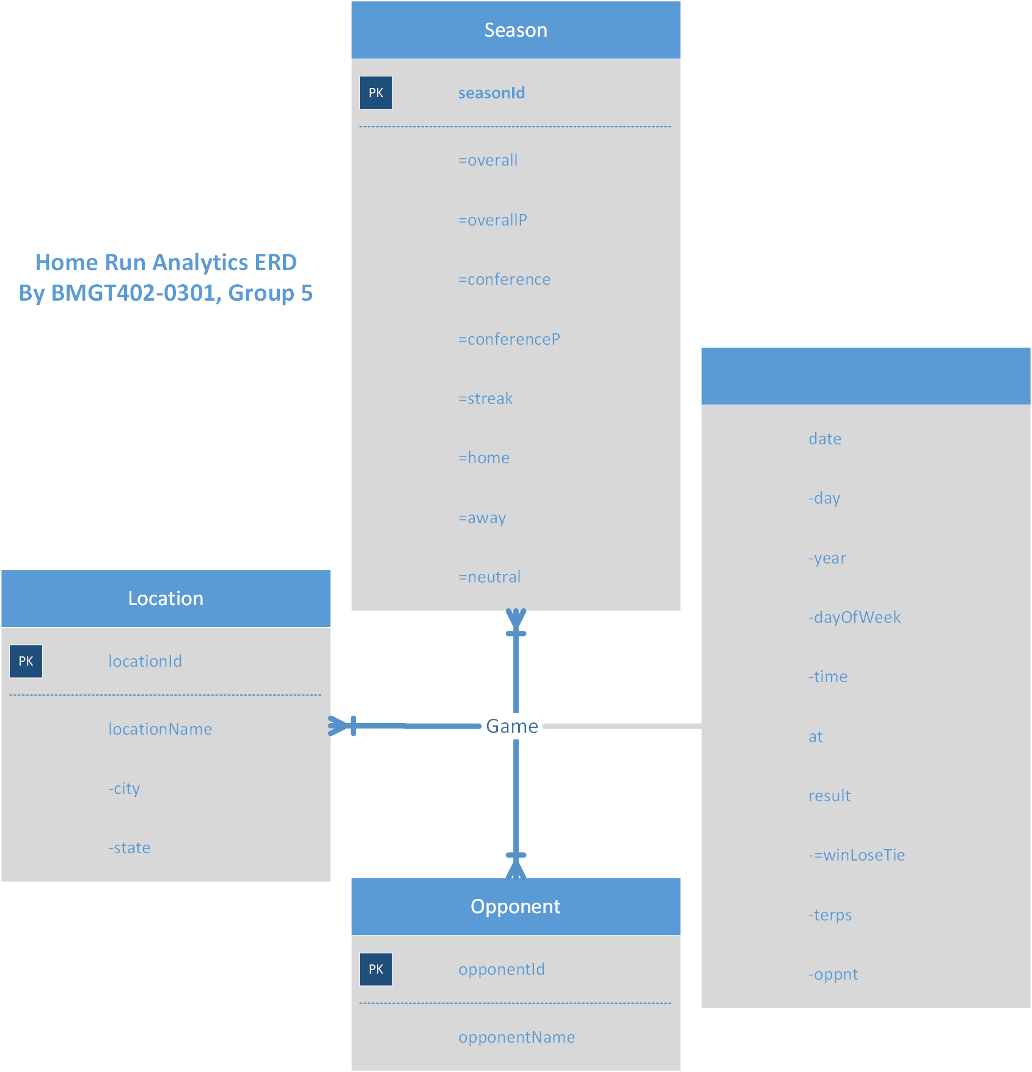

1. **Convert ERD into relational schema and identify primary and foreign keys.**
   1. Season(**seasonId**)
   2. Opponent(**opponentId**, opponentName)
   3. Location(**locationId**, city, state)
   4. Game(**gameId**, day, *year*, dayOfWeek, time, at, terps, oppnt, *opponentID*, *locationID*)
2. **Generate business rules and determine referential integrity respectively.**
   1. Business Rules:
      1. [R1] A season cannot be deleted from the database if there are any games in that season.
      2. [R2] A season’s year cannot be changed if there are any games in that year.
      3. [R3] An opponent cannot be deleted from the database if there are any games against said opponent.
      4. [R4] When an opponent’s ID is updated, the opponent’s ID in the corresponding game(s) should also be updated.
      5. [R5] A location cannot be deleted from the database if there are any games at said location.
      6. [R6] When a location’s ID is updated, the location ID for all games at that location should also be updated.
   2. Referential Integrity:

| **Foreign Key** | **Relation Name** | **Matching Primary Key** | **Base Relation Name** | **Business Rule on Deletion** | **ON DELETE** | **Business Rule on Modification** | **ON UPDATE** |
| --- | --- | --- | --- | --- | --- | --- | --- |
| year | Game | seasonId | Season | R1 | NO ACTION | R2 | NO ACTION |
| opponentId | Game | opponentId | Opponent | R3 | NO ACTION | R4 | CASCADE |
| locationId | Game | locationId | Location | R5 | NO ACTION | R6 | CASCADE |